Stroud HAF link (Half Term Activities program)
Leanne Sutton is the HAF lead for Stroud and can support any families in accessing the program.leanne.sutton@stroud.gov.uk
The Summer HAF programme will be running from 22nd July to 30th August 2024. HAF can only be offered to those in reception to year 11 who receive benefits-related free school meals.
The programme offers a range of activities for children and their families including family play days, football camps, music workshops, arts and craft and more and many of these activities provide food.
How can I get it? If you are booking for the first time you will need to create an account which can be done here: Register
If you have booked before please make sure you know your login details Sign In

Summer 2024 in Stroud

Bike Project: We are open for young people for :
Booked sessions on Wednesdays 2-6pm
Drop-in every Thursday and Friday from 2-6pm.
With new participants we prefer them to come to booked sessions first (when we have higher staffing ratios and can ensure they get sufficient support to settle). Booking calendar: https://bookwhen.com/accessbike
Referral form (please use where there are additional things we need to know about the young person, or when you aren't sure how we can best support them): https://app.upshot.org.uk/signup/063f6b3e/f3ce39c6bc98286a/
More information about the project: https://cscic.org/programmes/access-bike/
James Beecher Access Bike Project Manager 07482 104038

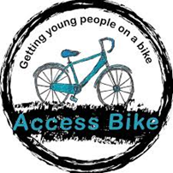

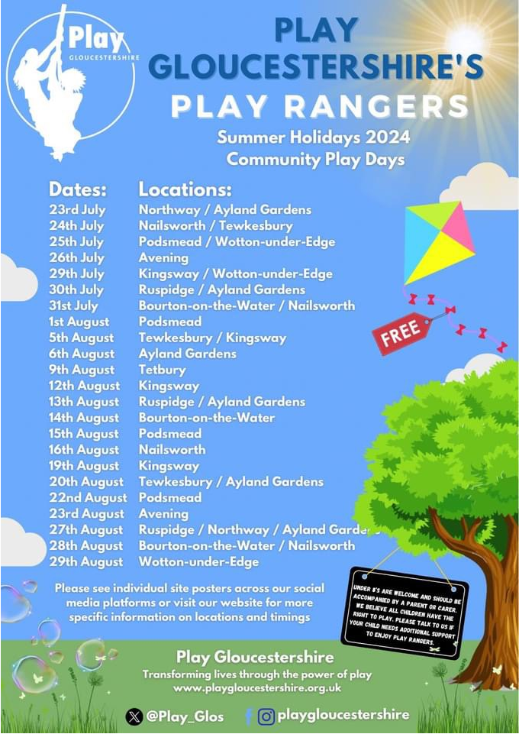

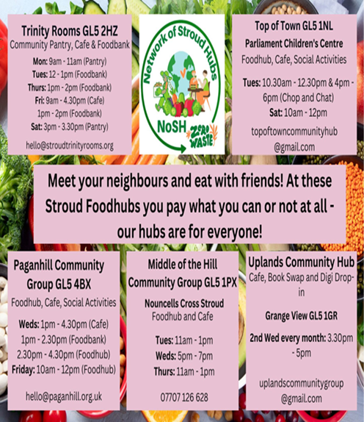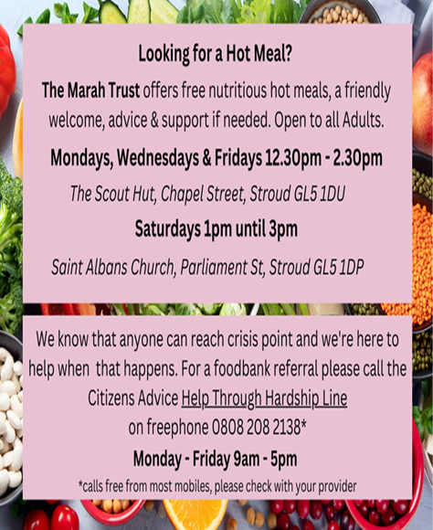

Please see links below for more fun ideas/events happening in Stroud
Stroud Rocks – this website takes you to all activities and fun days that are happening in Stroud

50 free things to do in Gloucestershire – takes you to a bucket list of activities that families can do for free in Gloucestershire.

